**Task 12: Jenkins Master & Slave Configuration**

In Jenkins, **master-slave configuration** (also known as **controller-agent configuration**) is a setup that allows Jenkins to distribute workloads across multiple machines.

1. Created 2 EC2 Instances, One as Master node & the other as Slave node

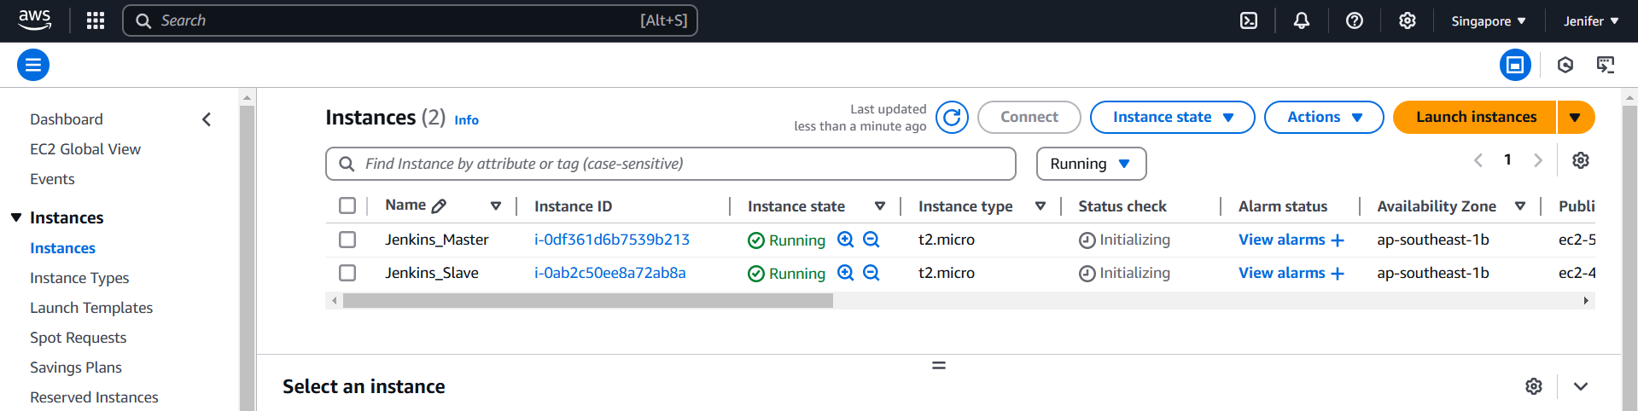

2. Jenkins has installed in the Master Node & Configuring Jenkins server

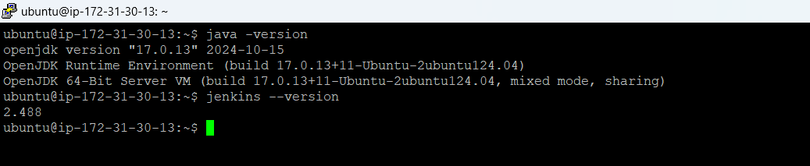

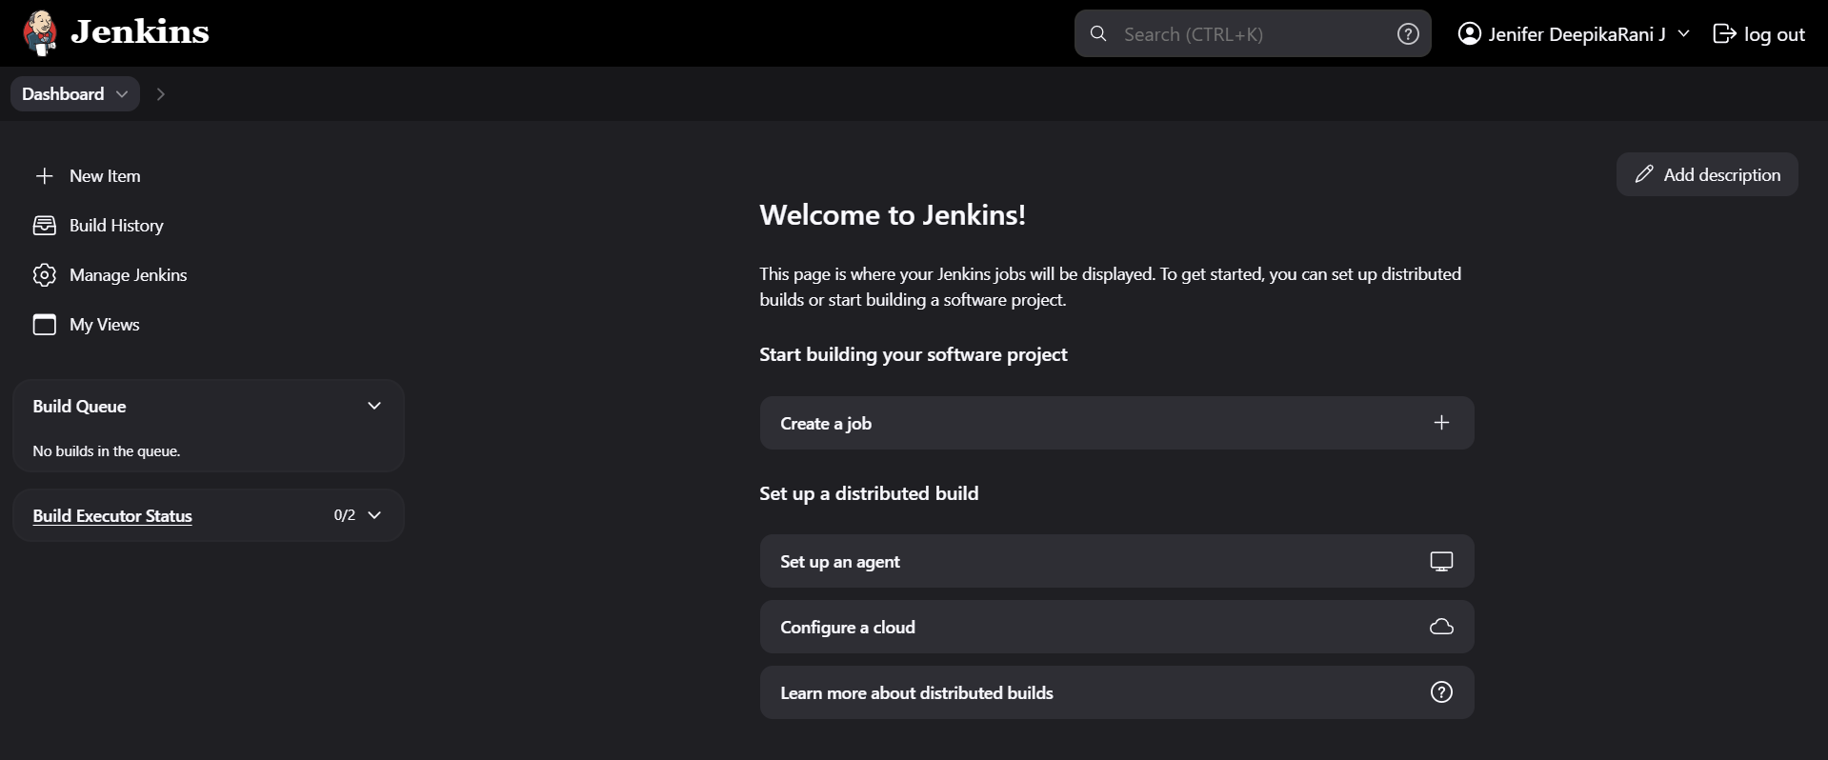

3. Configuring Slave Node in Master Jenkins Machine, Click on Nodes

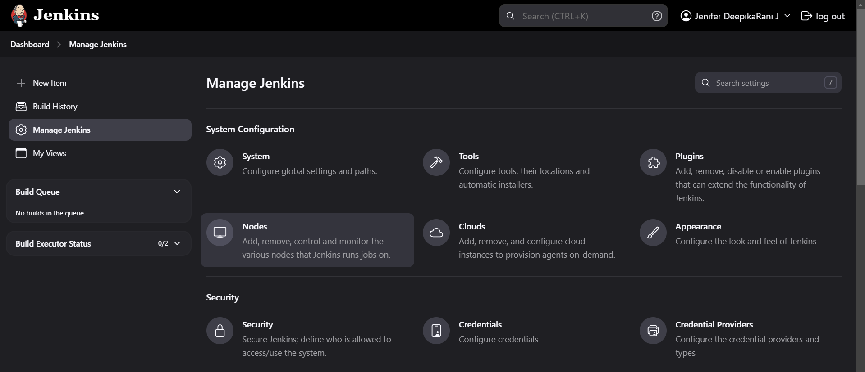

4. Click on New Node

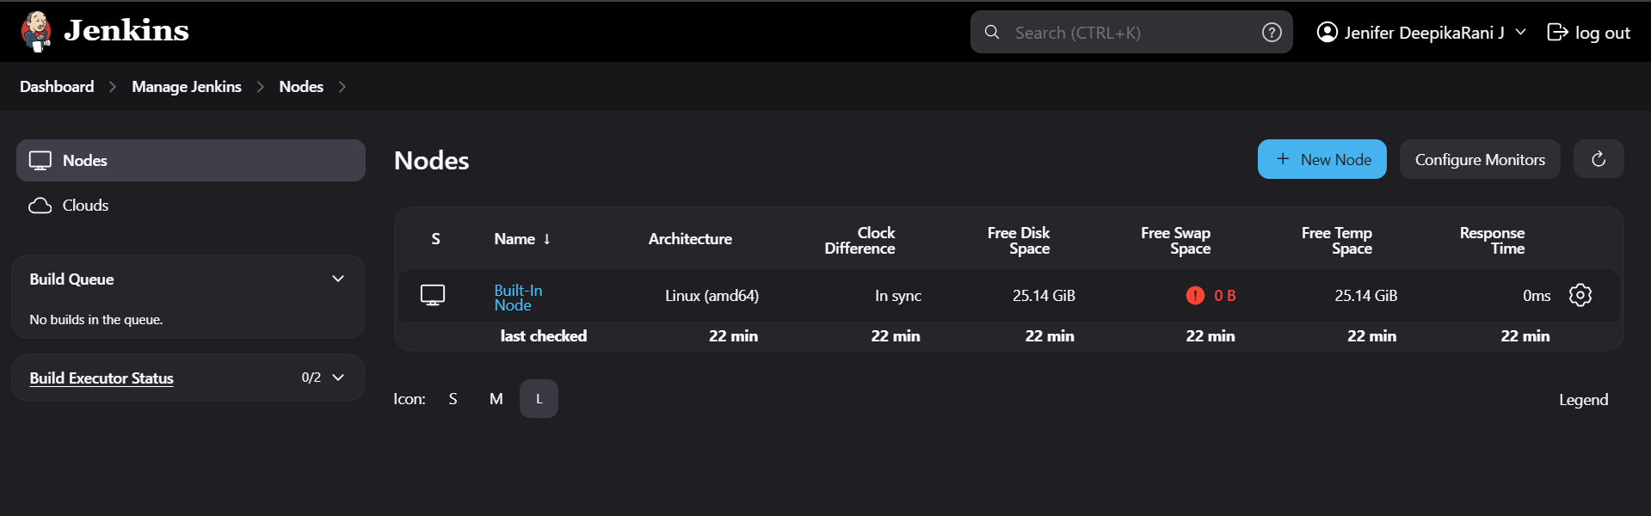

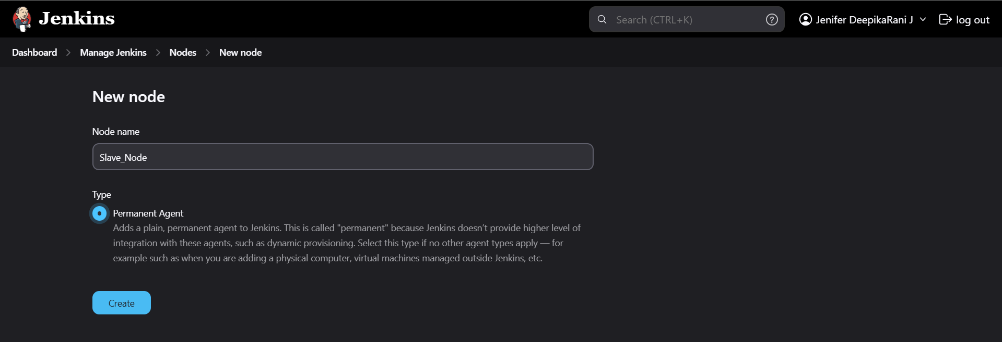

5. Slave_Node Configurations has done

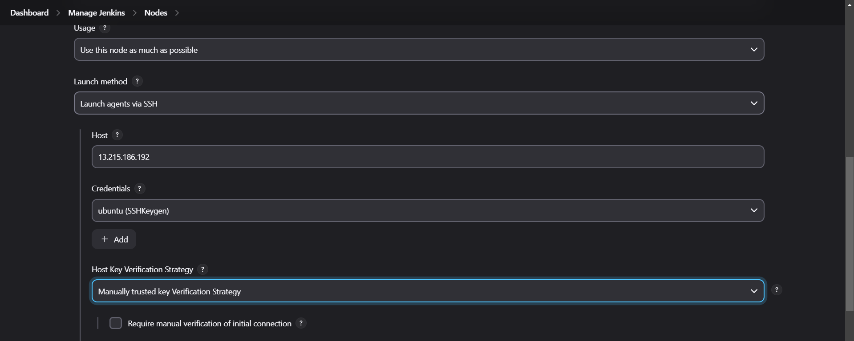

6. The New Node(Slave_Node) has added in the nodes list

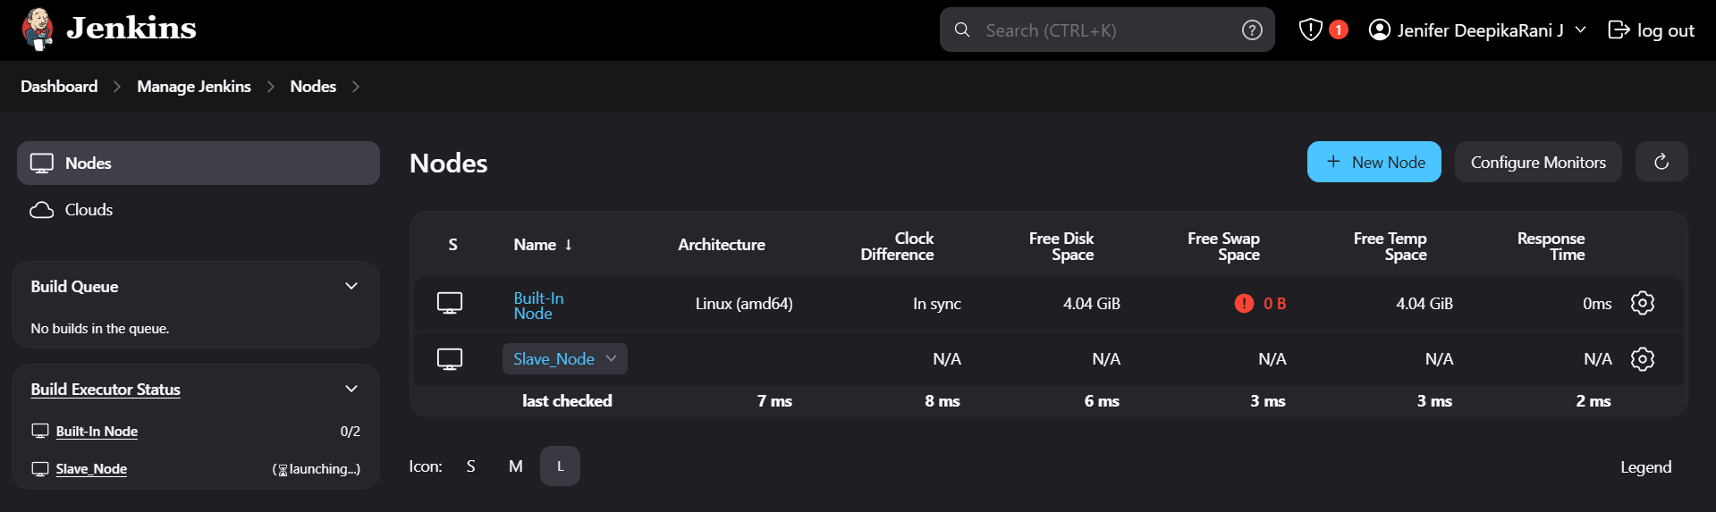

7. A new job configured in Master node

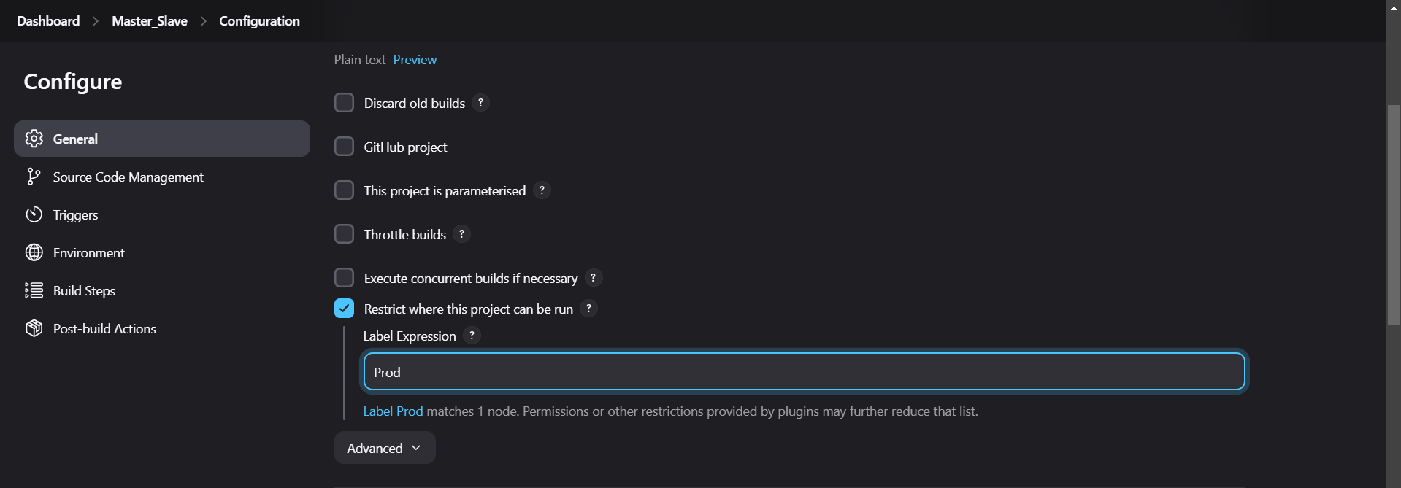

8. Build Step Added

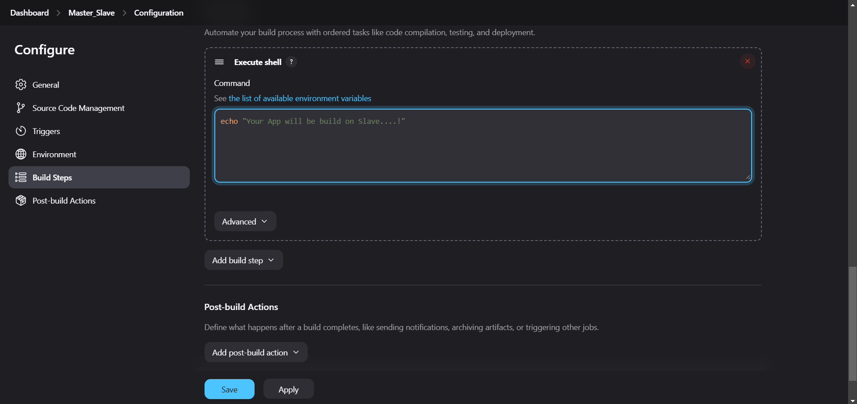

9. The Console Output

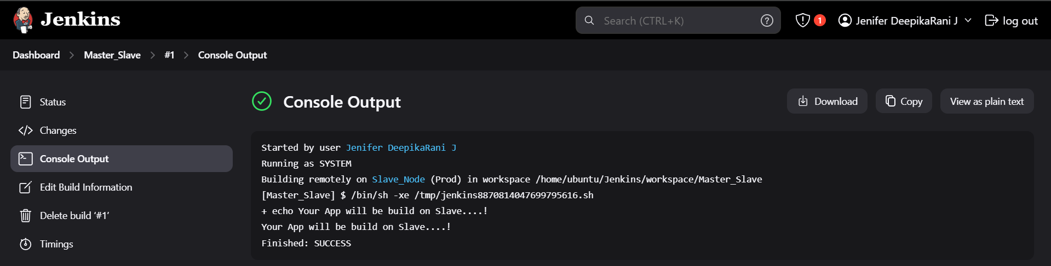

10. The Job Built in Master Node has reflected in the Slave Machine

